**Al Imam Mohammad Ibn Saud Islamic University**

**College of Computer and Information Sciences**

**Information Technology Department**

|  |  |
| --- | --- |
| **Course Title:** | Web Systems |
| **Course Code:** | IT 390 |
| **Course Instructor:** | Dr. Amir Mohamed Talib, T. Naflah Alrumyyan, T. Wed Alateeq & T. Sarah Alrashed |
| **Assessment:** | Project (phase two) |
| **Semester:** | First 2021 |
| **Due Date:** |  |
| **Marks:** | 7 |

|  |  |  |  |
| --- | --- | --- | --- |
| **Student Name (in English):** | **Student Name (in Arabic):** | | **Student ID:** |
| **Alanoud Alhabradi** | العنود الحبردي | | **439018954** |
| **Areej Alrasheed** | أريج الرشيد | | **440019111** |
| **Laila Almugren** | ليلى المقرن | | **440022837** |
| **Lama Alqarni** | لمى القرني | | **440020128** |
| **Shahad Almutlaq** | شهد المطلق | | **440019491** |
| **Section No.:** | | **373** | |

|  |
| --- |
| There will be no extension in the submission deadline.  No late submission will be accepted. |

|  |  |  |
| --- | --- | --- |
| **Official Use Only** | | |
| **Question** | **Student Marks** | **Question Marks** |
| 1 |  | 7 |
| **Total** |  | **7** |

Home Page:

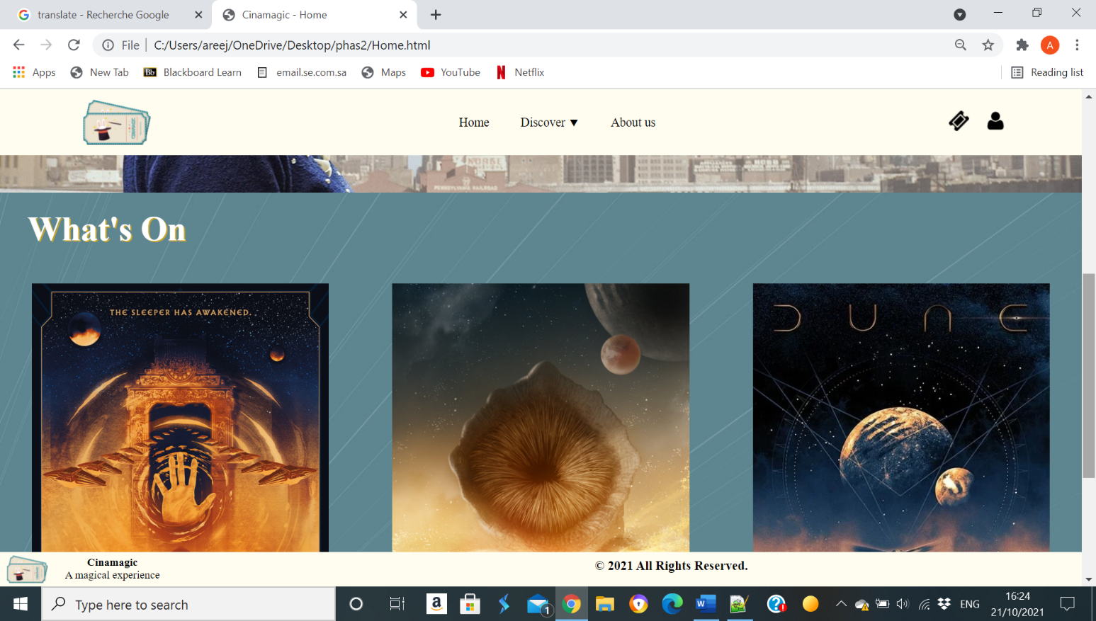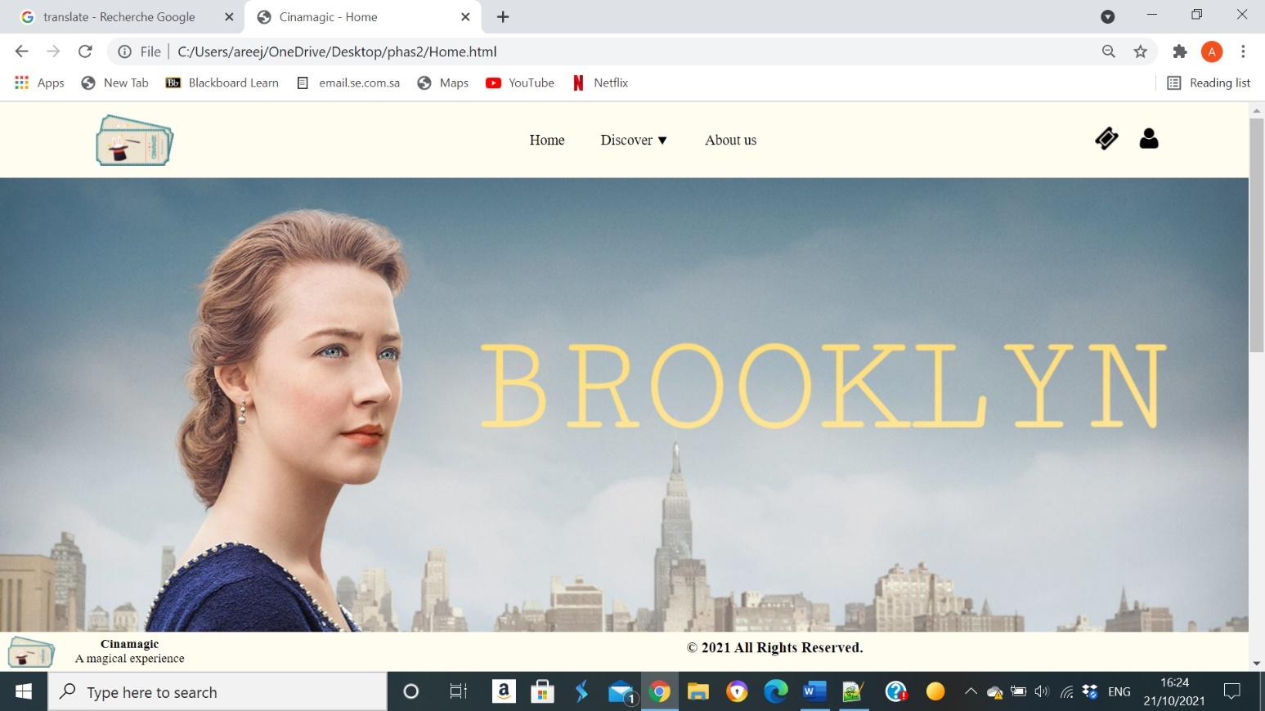

Discover Showing now page:

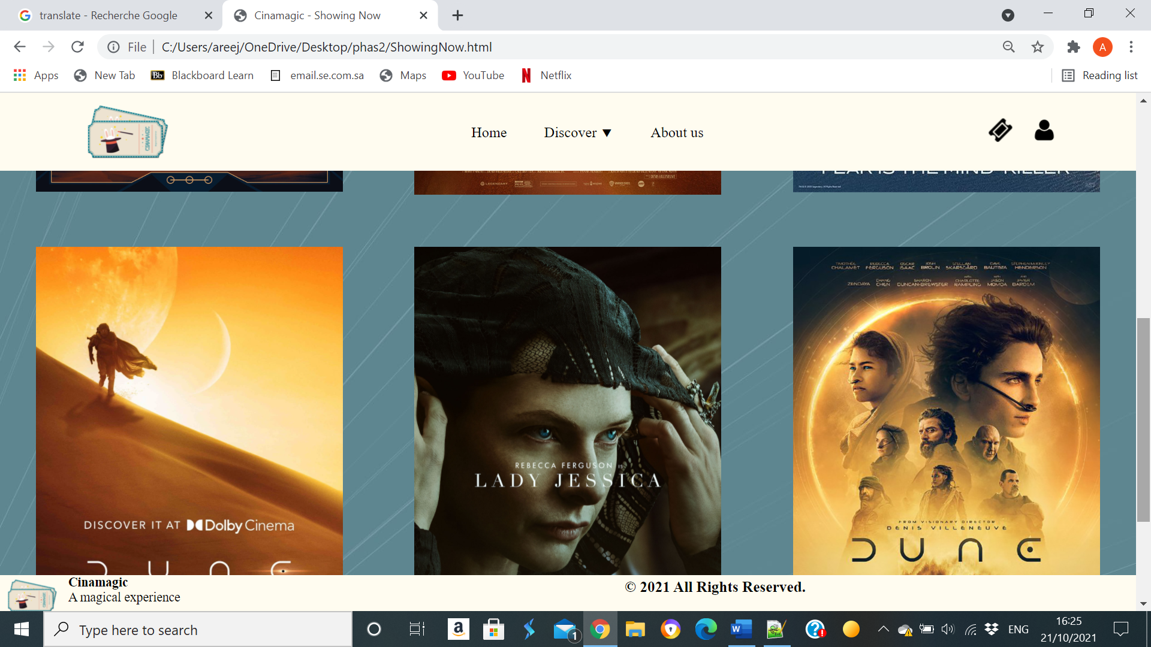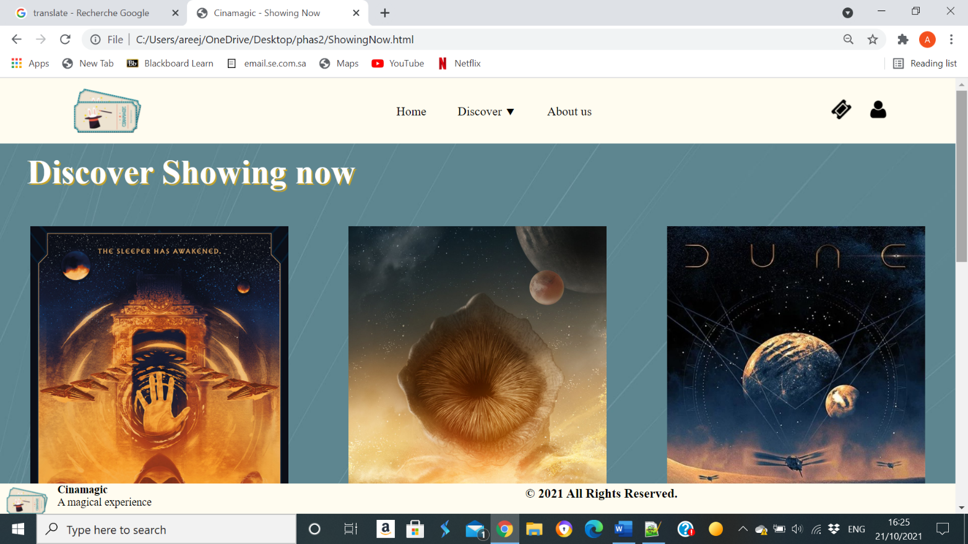

Discover Coming page:

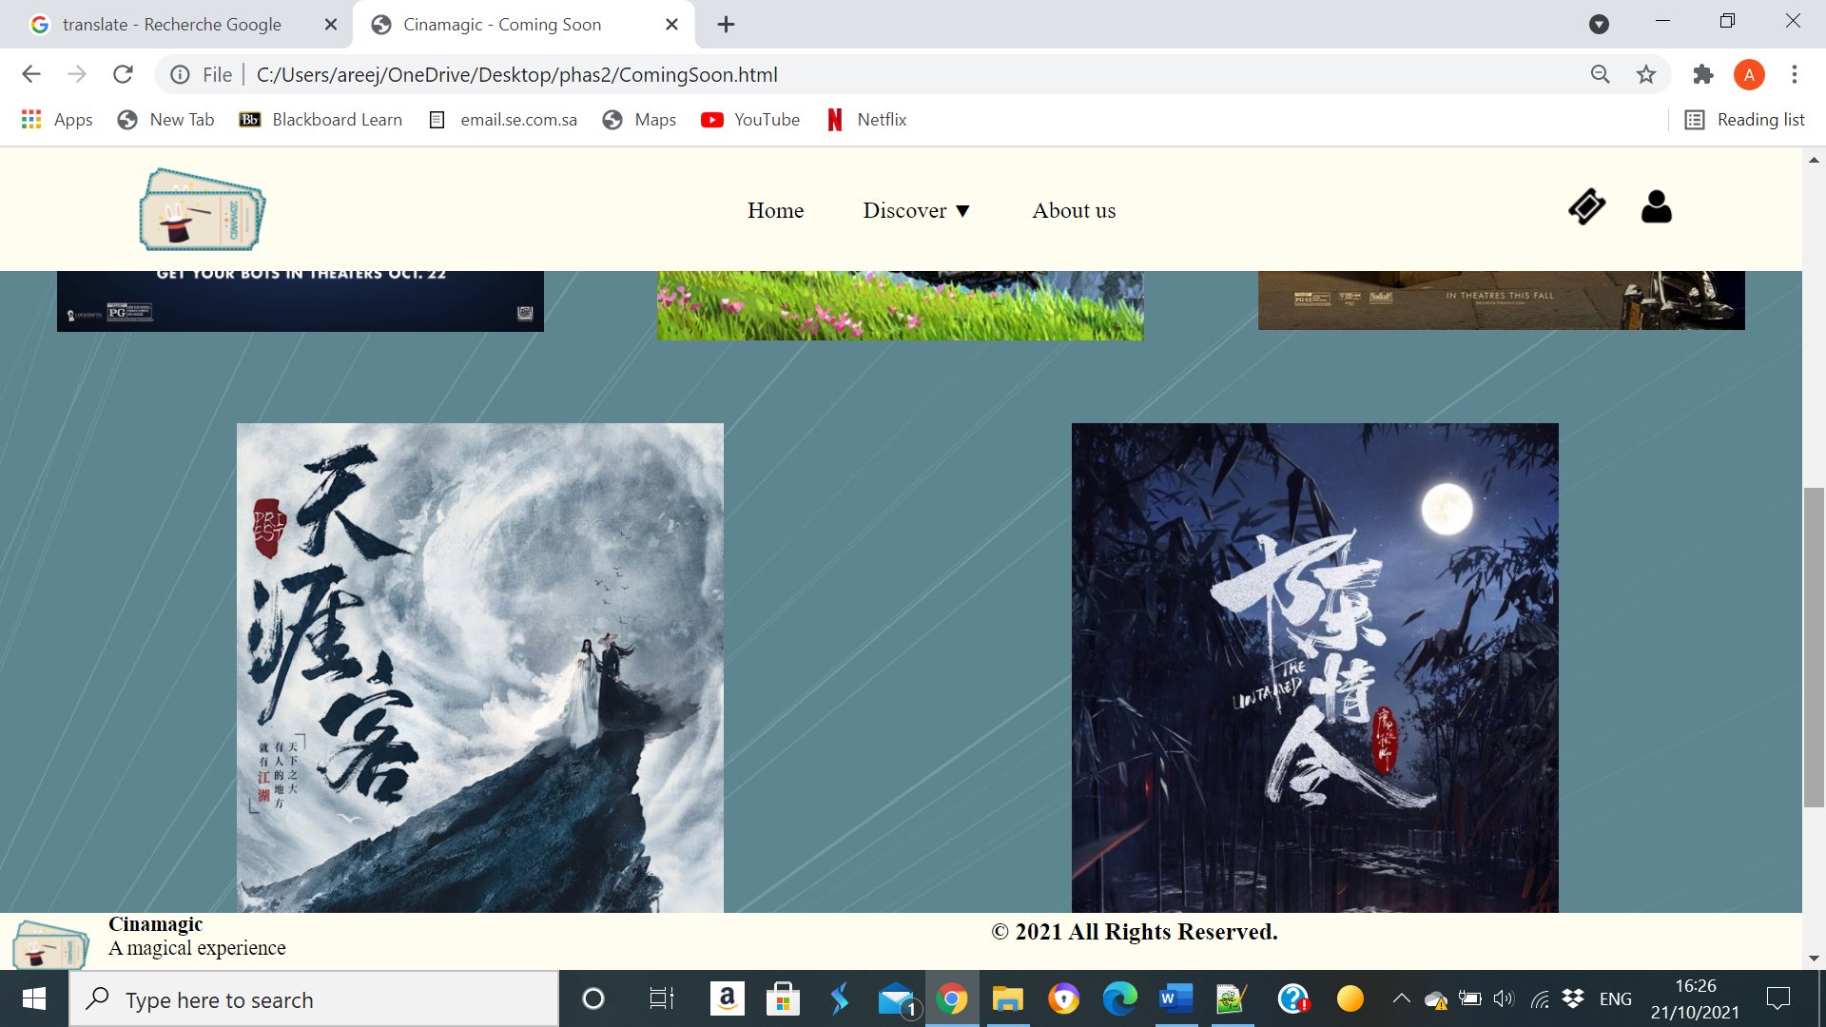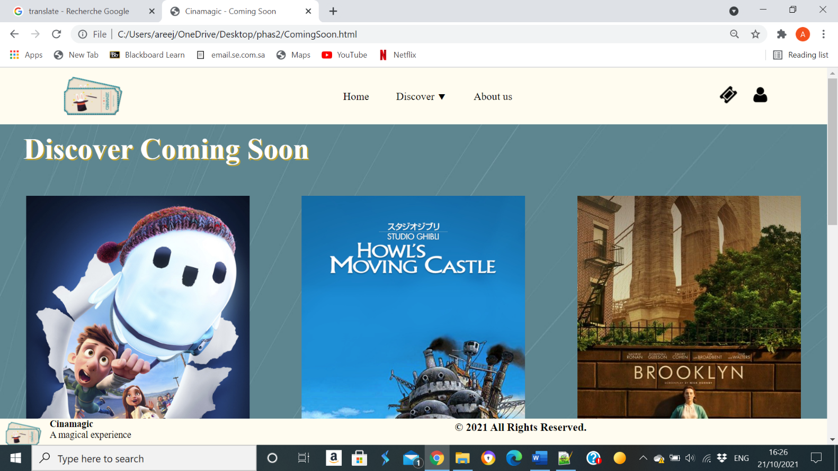

About us page:

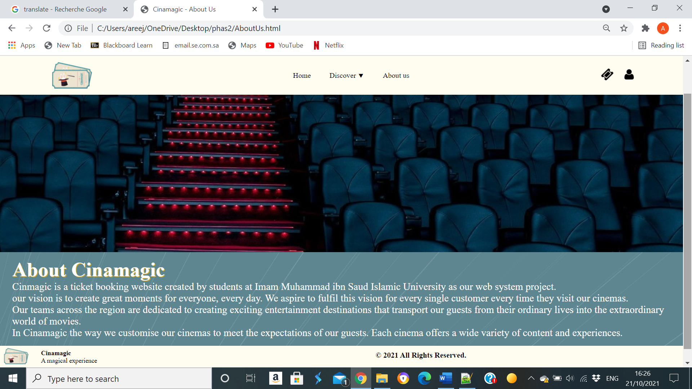

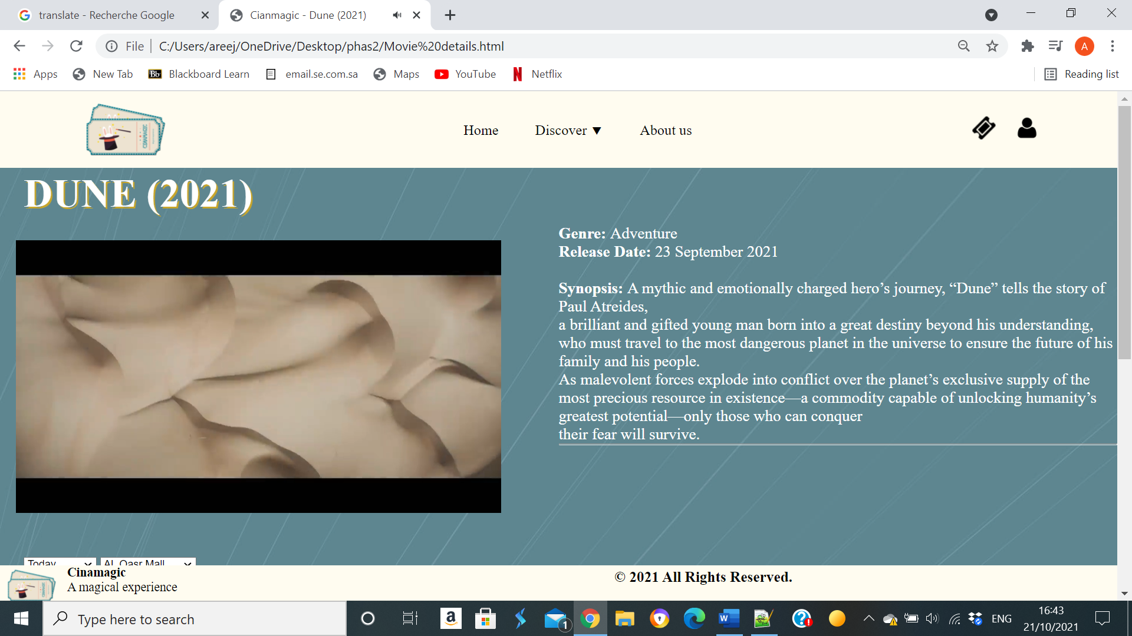Movie details page:

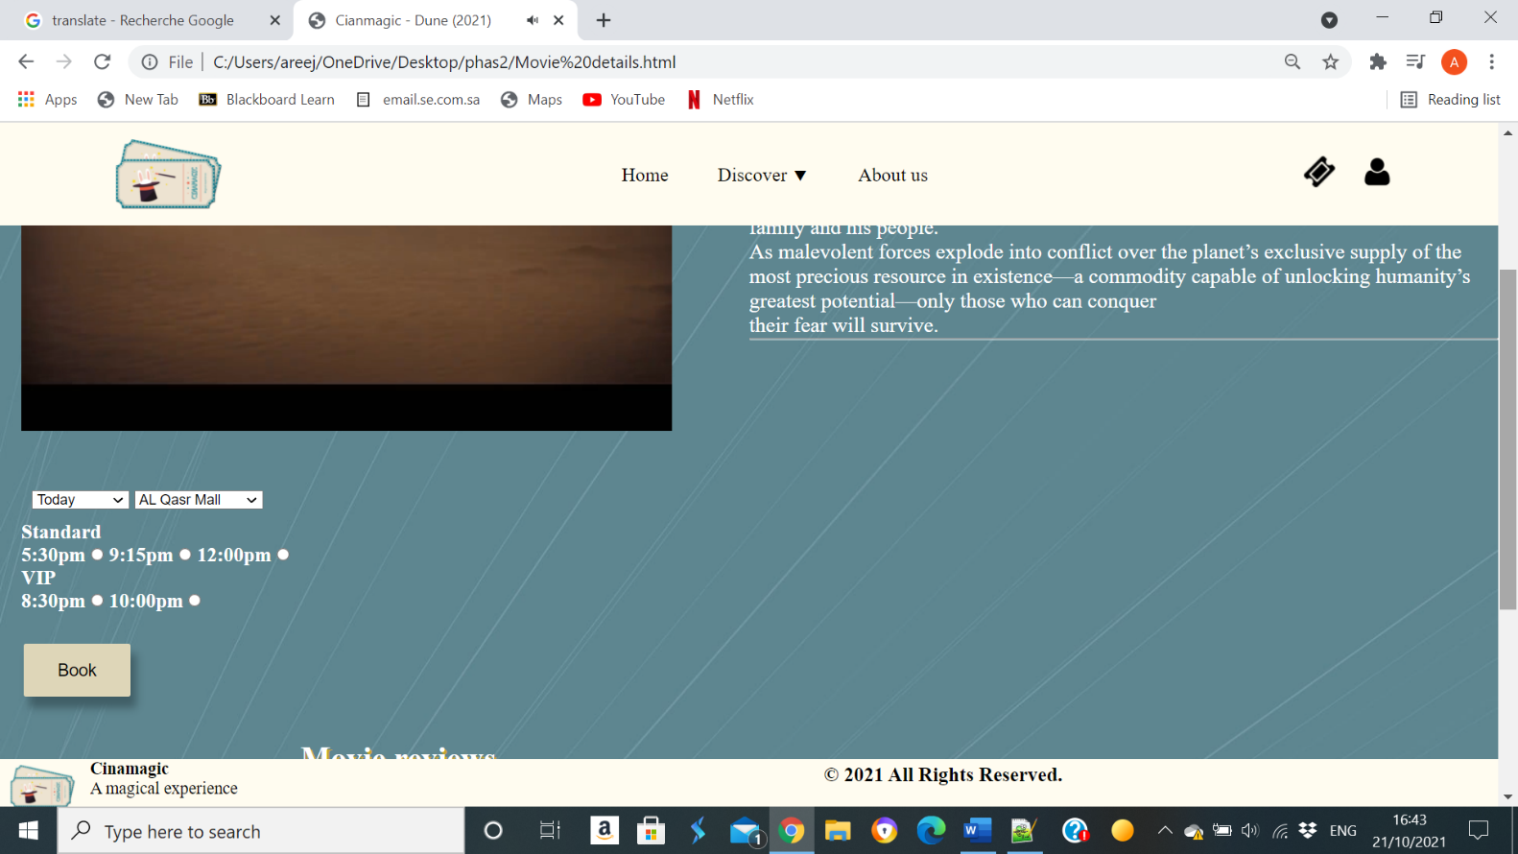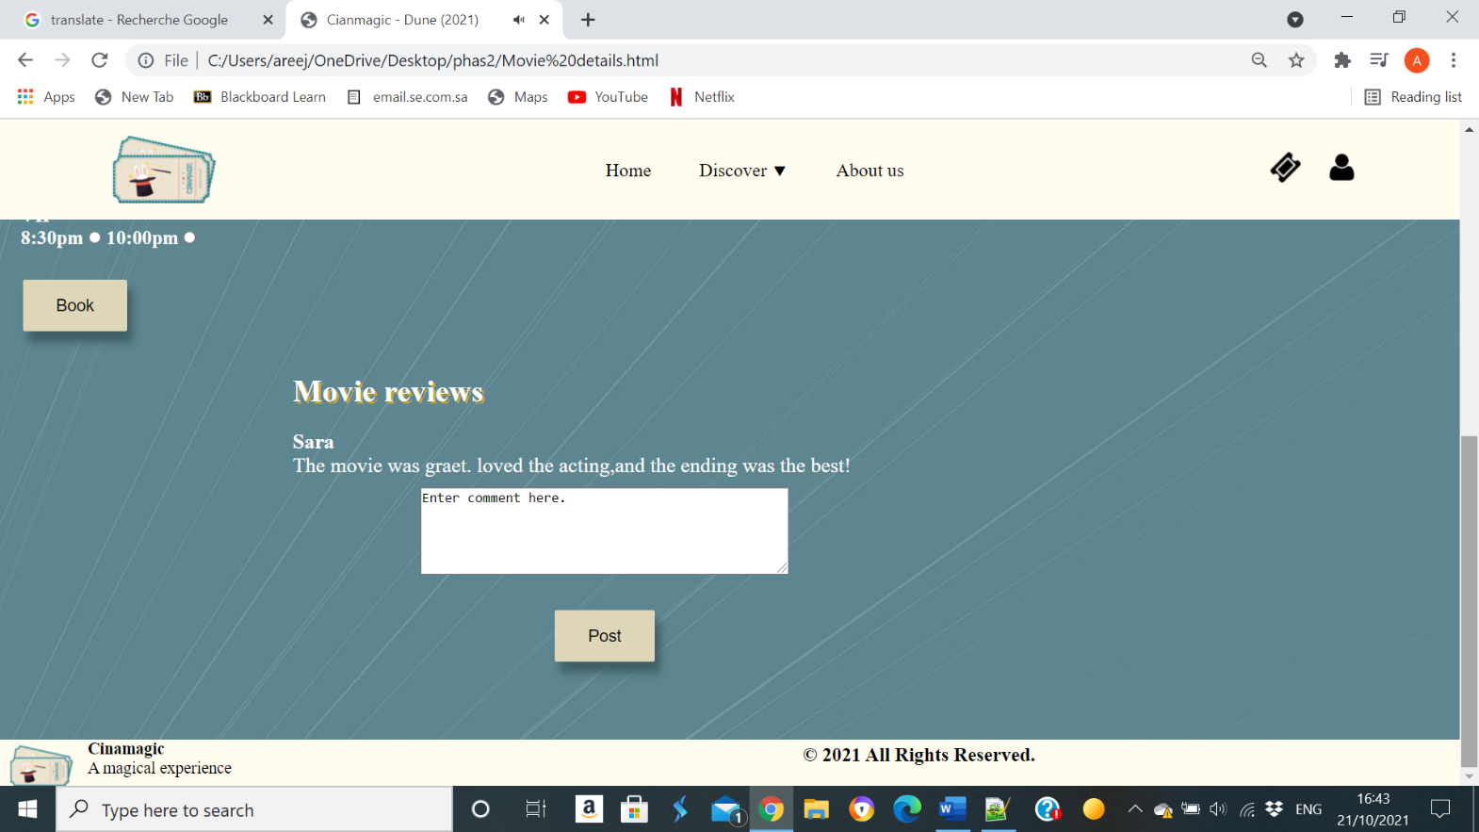

Booking page:

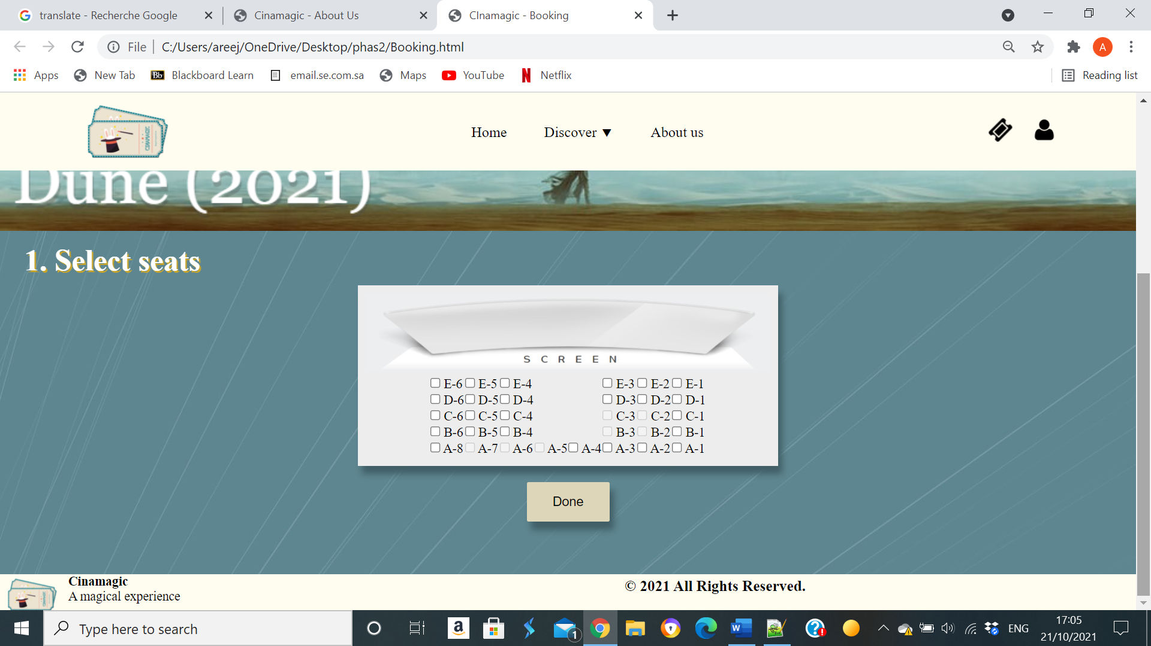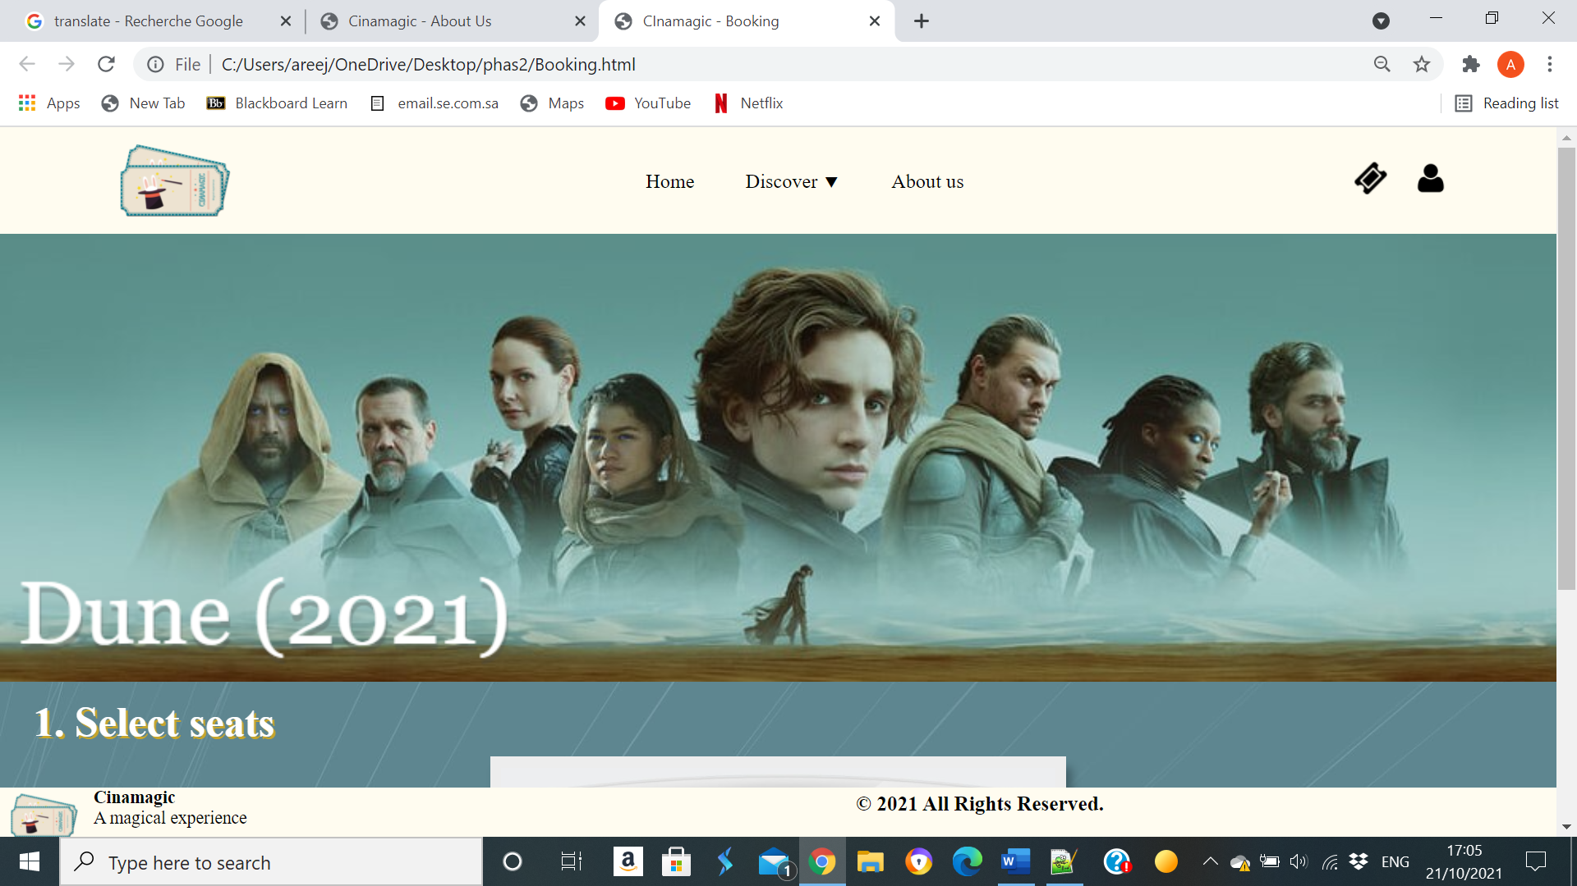

Payment Page:

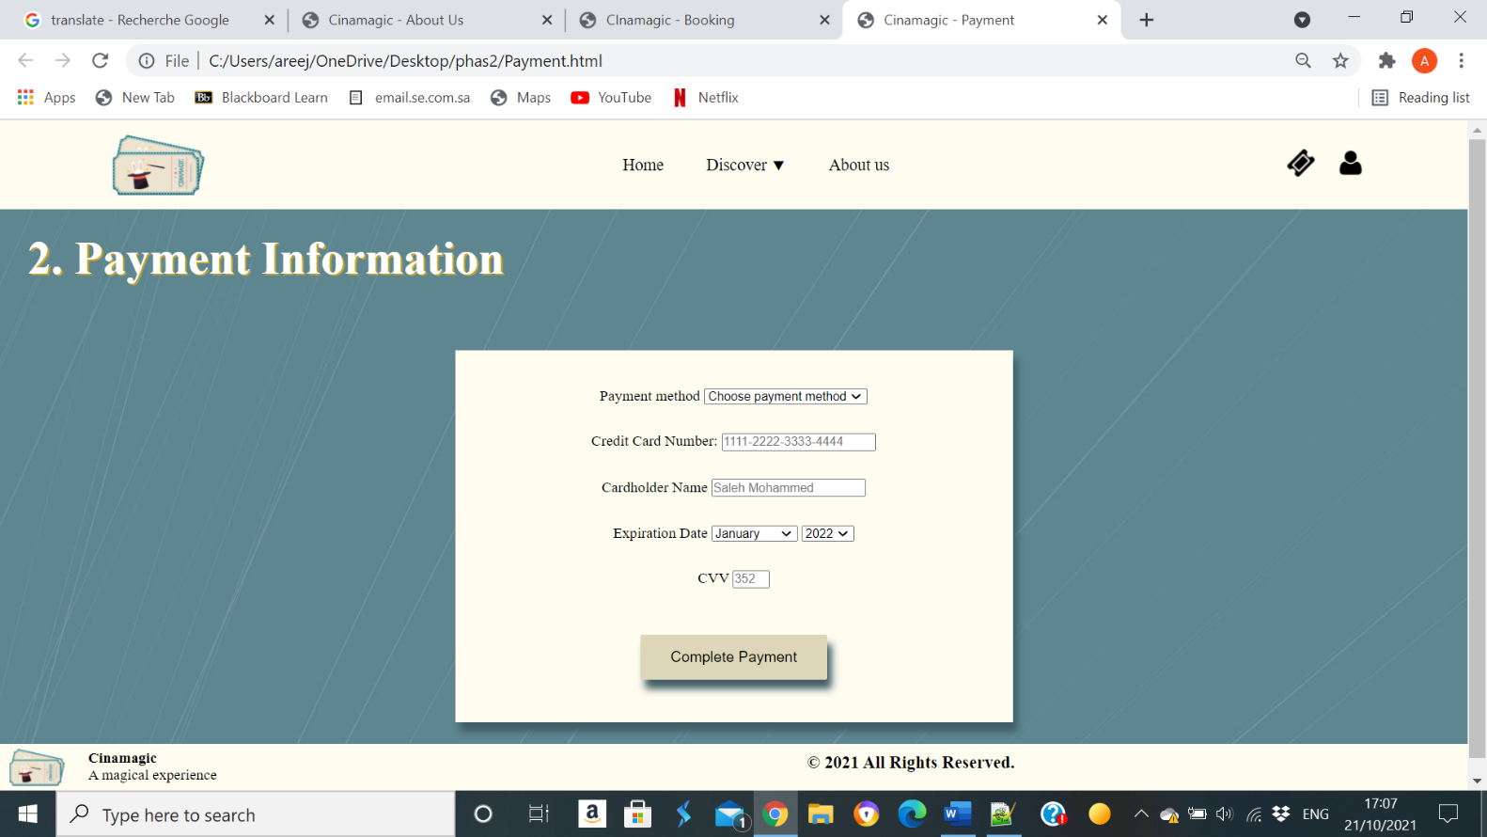

Ticket Page:

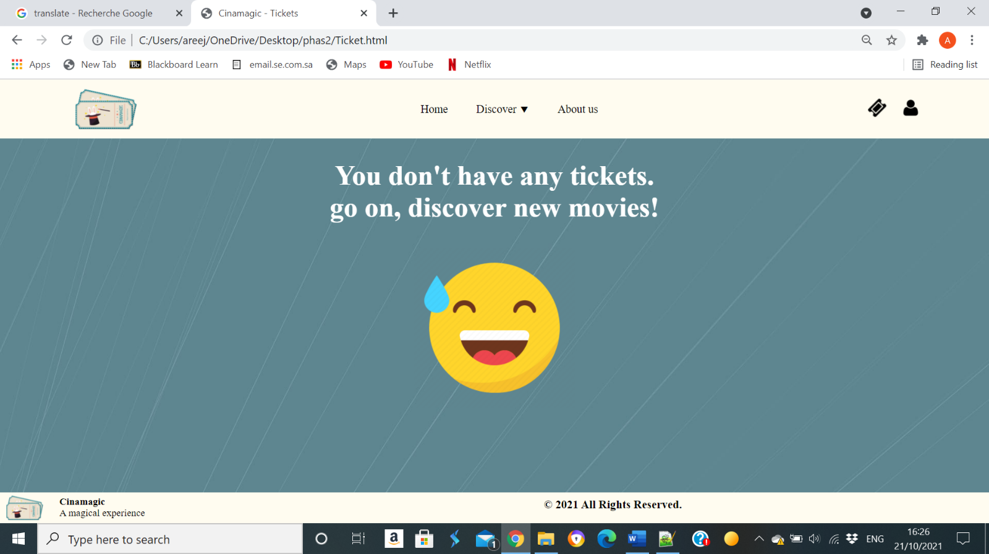

Login As.. Page:

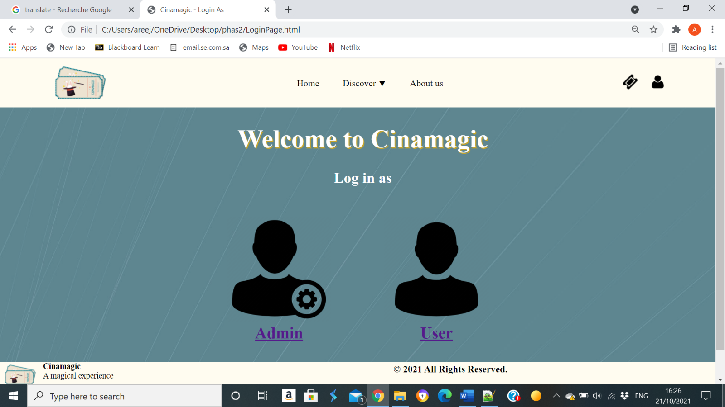

User login Page:

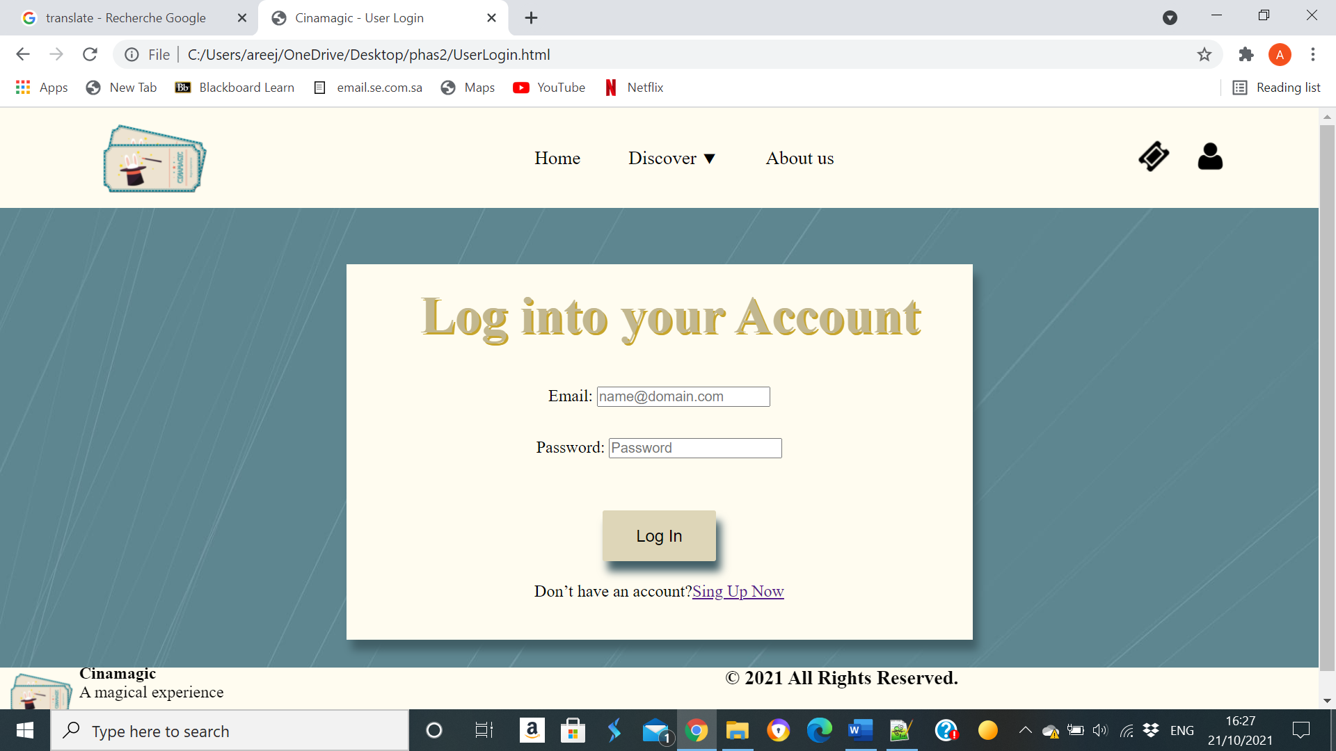

Sing up Page:

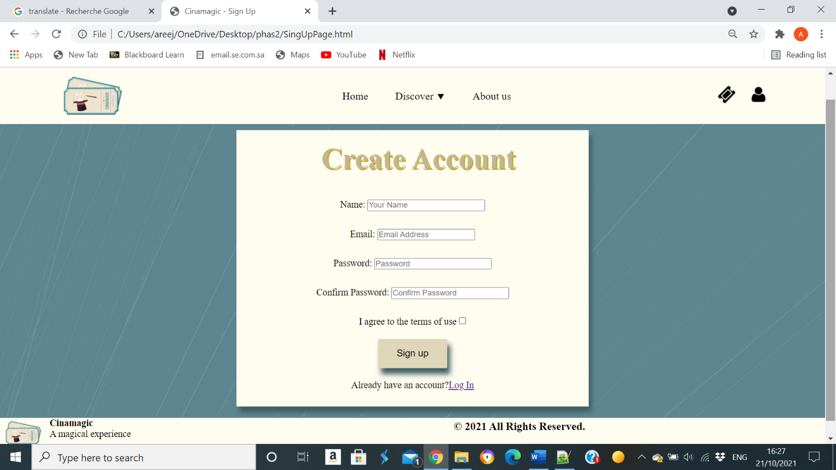

Admin login Page:

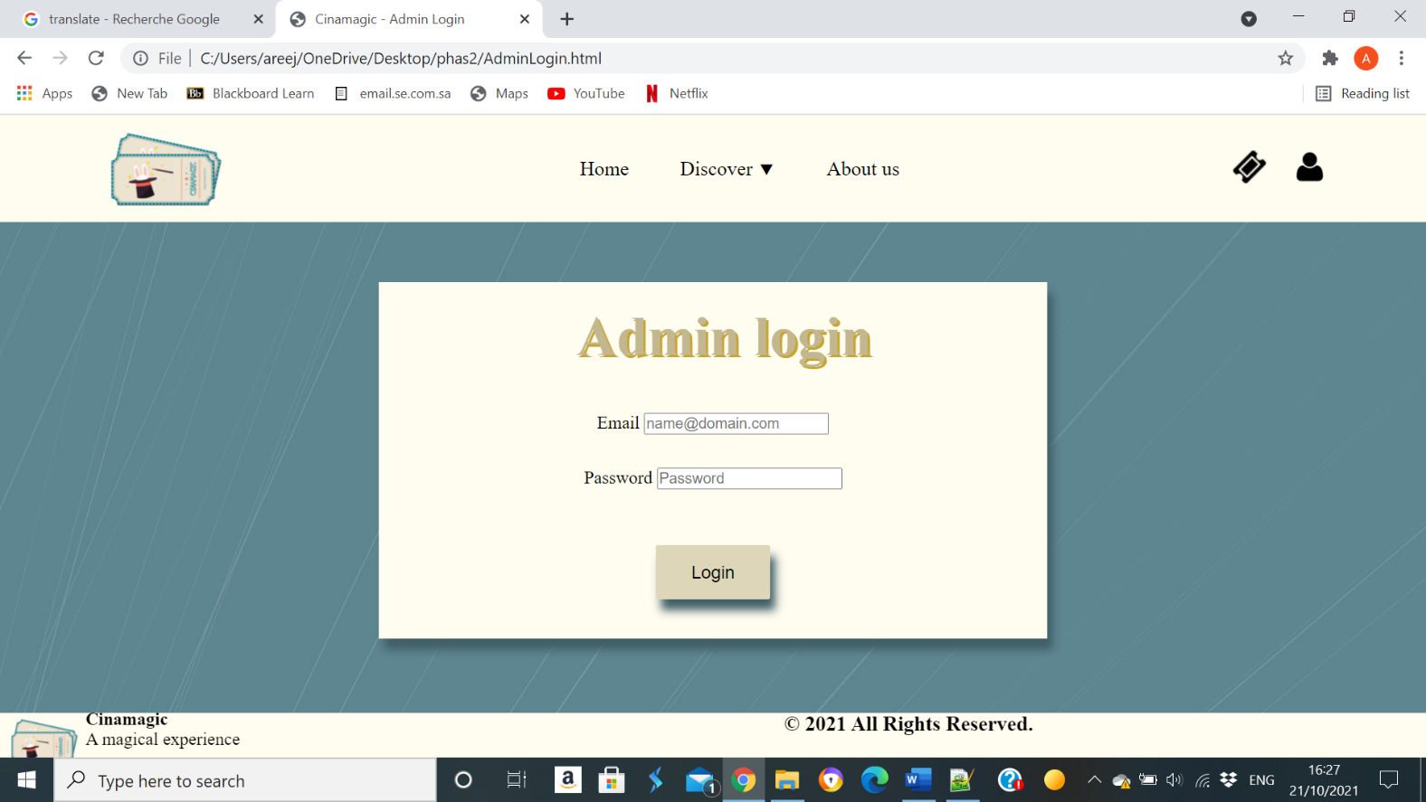

Admin control Page:

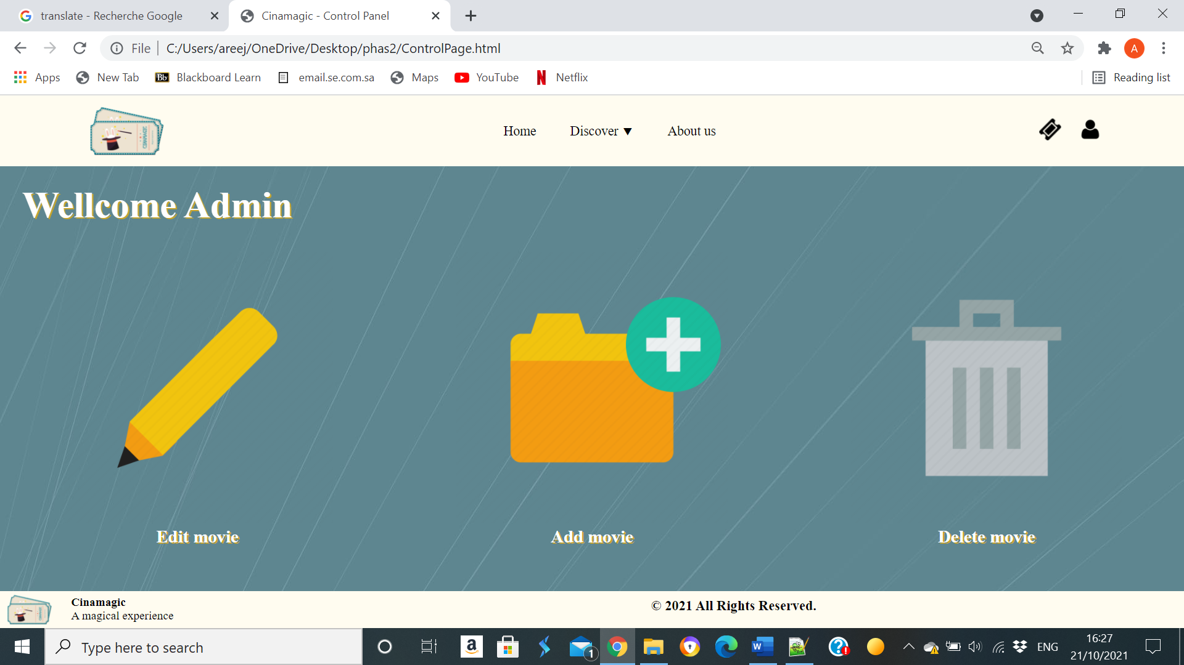

Edit Item Page:

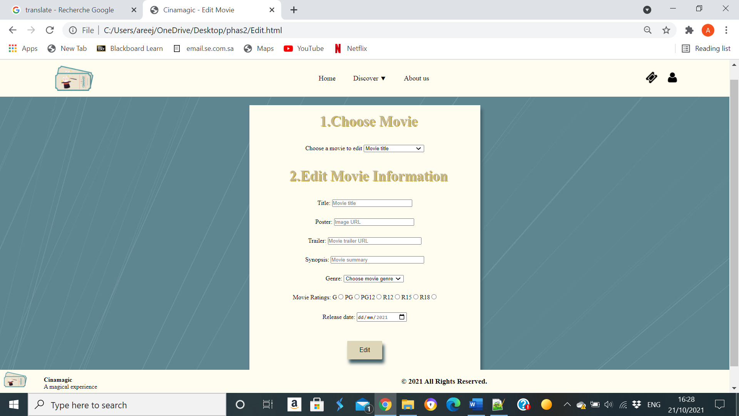

Add Item Page:

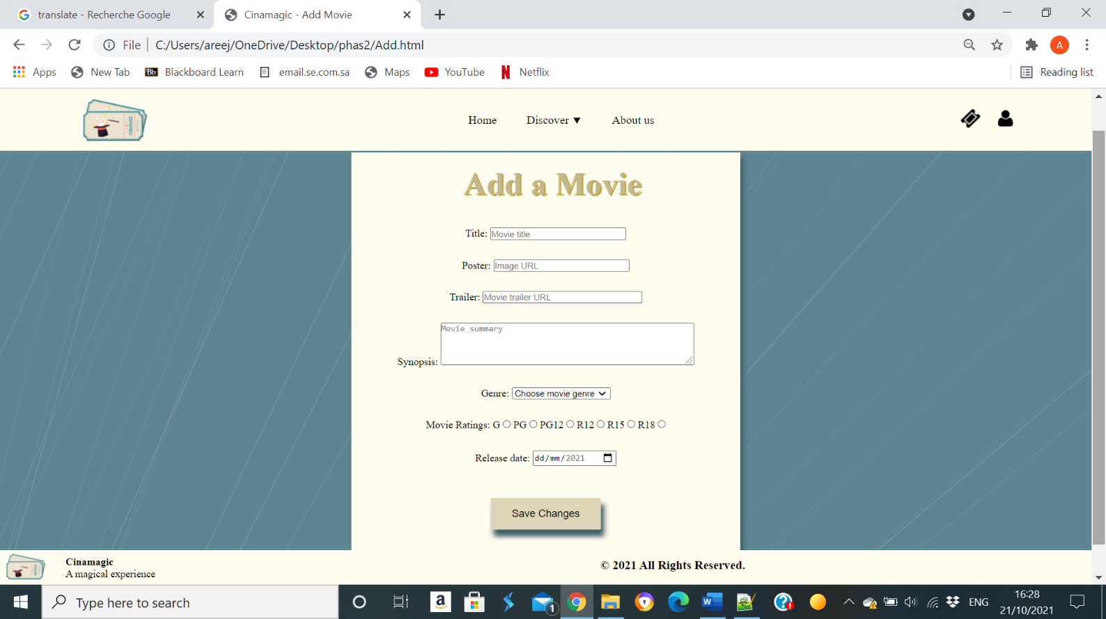

Delete Item Page:

